# Word Press Users Guide

Word Press is a website content management system. It allows users to update their content and add pages to the website and change the appearance where necessary. This guide will take you through the basics of adding and editing page content, as well as uploading images / media to use on the website.

## Website Logins:

**Website:** Celia Tubbs Marketing Solutions

**URL:** <http://www.wildlifeandphotographysafaris.co.uk>

**Word Press Admin URL:** [<http://www.wildlifeandphotographysafaris.co.uk> /wp-admin](http://www.celiatubssmarketing.co.uk/wp-admin)

**Word Press Username:** WLPS

**Word Press Password:** RedKite

**Word Press Role:** Editor

The editor has cut down permissions that make updating the site easier.

**Admin Username:** Admin

**Admin Password:** 32ChantryDrive

The admin has full permission to the whole site and is able to change anything.

## Email Address:

**Email Address:** [info@wildlifeandphotographysafaris.co.uk](mailto:info@wildlifeandphotographysafaris.co.uk)

**Password:** RedKite

**Mail Login:** <http://webmail.wildlifeandphotographysafaris.co.uk>

## Login:

To login to Word Press navigate to the Word Press Admin URL and enter your Word Press Username and Password into the screen as shown below. And click the Log In button.

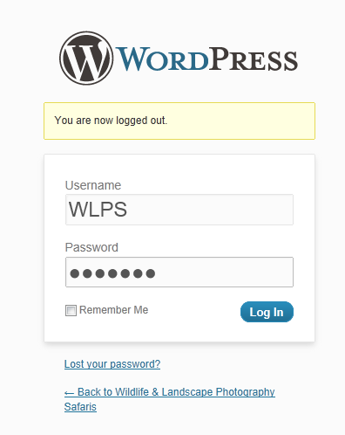

Having logged in you will be presented with the Word Press Dashboard as below. On the Left Hand Side of the screen is the Menu which will be used mainly during the rest of this document.

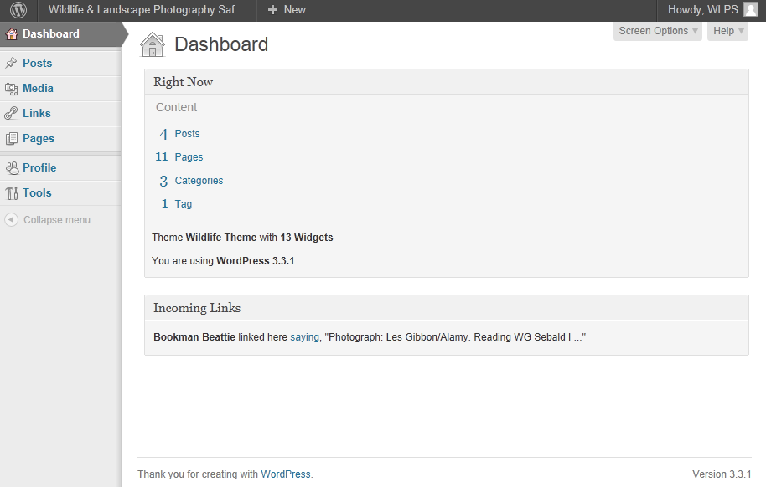

Please note that while logged in, if you return to the website then you will also see a tool bar at the top of the screen, as below. This does many of the same functions as the Dashboard menu but allows you to carry out the operations while viewing the site at the same time.



## Log Out:

To log out of the Admin section of the site, click the drop down at the top RHS of the screen and click the Log Out button.

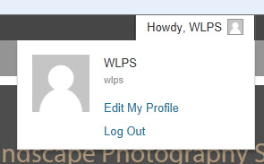

## Adding Media:

Before you can place an image onto a page you need to add it to a media library first. This is simply done by following the steps below:

**N.B.** Before uploading an image make sure it is a relativity small size. This can be done in Photoshop or similar. A good size for an image is 300px width. This then can be scaled down and won’t take too long to load on the page.

1. From the Dashboard Menu on the LHS click the Media Button.

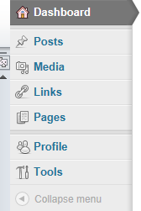

2. The Media Library will open showing you the images you already have uploaded ready for use. From the top of this page click the Add New button.

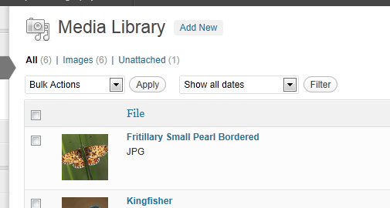

3. Click the Select Files button and then navigate to the file and select it. The file will then automatically be uploaded.

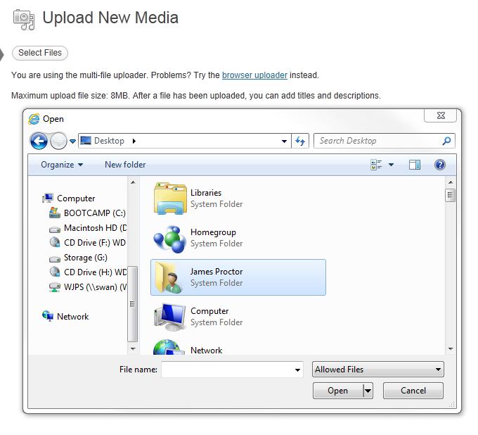

4. Once uploaded you will see a form display below which allows you to provide Meta Data for the image. You must provide a title, the other data is optional. Finally click the Save all changes button.

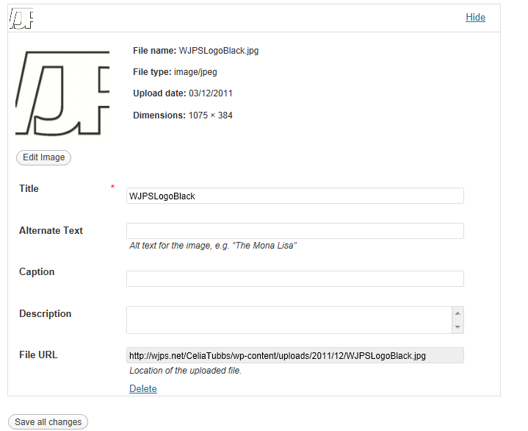

5. You will then be returned to the media library where you will see the new image that you have uploaded along with all the other images in the system.

## Adding a Page:

1. From the Dashboard Menu on the LHS click the Pages Button.



2. The Page Library will open showing you the pages you already have. From the top of this page click the Add New button.

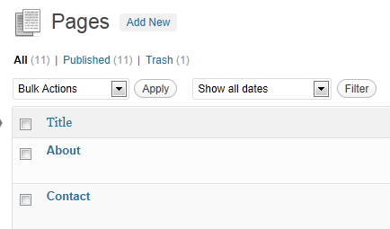

3. The Add New Page screen is made up of a number of elements. Firstly at the top of the page is the title area. In here enter the title for the new page.



Next is the main content area for the page. This is where all your text and images go. The tool bars works just the same as a formatting tool bar does in word. However you don’t need to worry about fonts or colours as the system is automatically set to manage this for you. There are a couple of things to notice in the tool bar.

Firstly at the top you have Upload / Insert buttons. These allow you to add the media from the media library. To Add an image choose the first icon. This will bring up the Add an Image screen. In the tabs at the top of this page select Media Library, and then find the image you want to add and click Show. Finally look towards the bottom of the screen and you will see a button that says “Insert into Post” click this to add the image into the text area. The image is then drag able in this area as in most word processors.

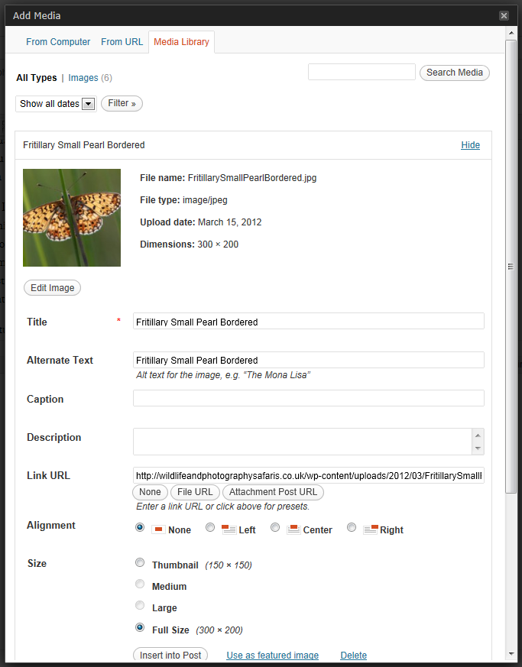

To expand the formatting tool bar make sure you have clicked the final button on the top row of the menu. Type in your text and then use the formatting options to lay it out as you would like it to look. If you want a piece of text to be a heading then highlight it and from the drop down on the second row select Heading 1. You can also use this to format other types of text, i.e. sub headings and so on.

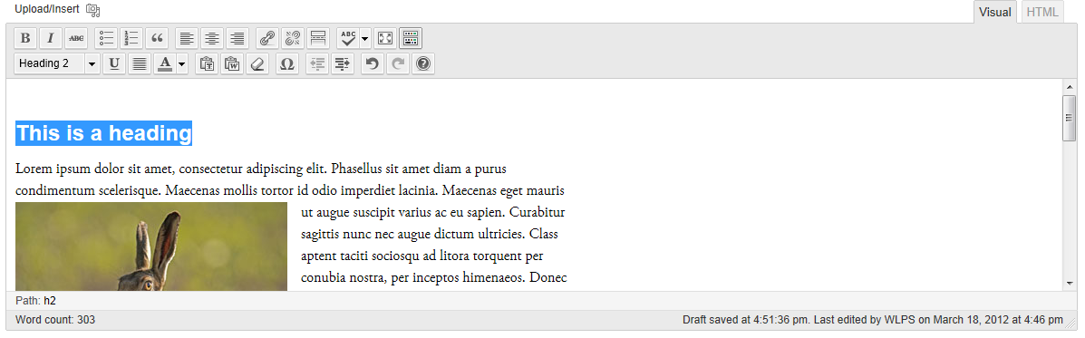

Once you are happy with the content you can alter the page attributes if required. By give a page a parent it means that the page sites underneath the parent in the page structure. Also always leave the Template to Default Template and Order to 0.

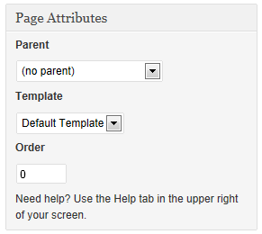

Finally the publish options. If you are working on a page and not yet ready to release it then click the save draft button. You can see how the page looks by clicking the Preview button. Once the page is complete and ready to release then click the Publish button. A published page will show on the live website, a draft wont.

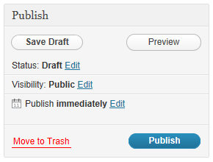

**N.B.** Pages will automatically be populated into the site menu at the top of the page. If this needs changing then please contact WJP Software who can provide support for this.

## Editing a Page:

Editing a page works in exactly the same way as adding a page. However there are a few subtle changes.

1. From the Dashboard Menu on the LHS click the Pages Button.



2. The Page Library will open showing you the pages you already have. Click the Edit button relating to the page you want to make changes to.



3. Finally either save a draft of publish the page directly to see the changes on the website.

## Adding a Workshop:

Adding a workshop is slightly different and there a few steps required. Workshops are added as posts.

1. From the Dashboard Menu on the LHS click the Posts Button.



2. The Posts Library will open showing you the posts you already have. Click the Add button to add a new post.

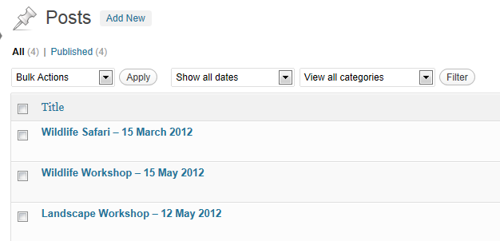

3. Posts work in the same way as Pages. So enter your Post Title (Workshop – Date), and the details below. And Save the draft.

4. Now set up the categories. Always check Event, this will make sure it shows on the full list of Upcoming Dates.

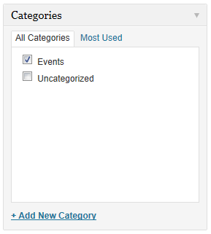

5. If you want the workshop to appear on the website in the upcoming date’s list you must add a tag to the page. The tag is “TopList”. After typing in the tag name, click the Add button.

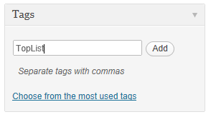

6. Finally update / save the post.